**Chapter 1**

**Laplace Transformation:** Let the function be defined for all positive values of, then multiply by and integrate it with respect to from zero to infinity. If the resulting integral exists (i.e., has some finite value), it is a function of, may be real or complex, say.

(Domain must be +ve).

(Domain 0 to + infinity where 0 is excluded).

**Important formulae:**

|  |  |
| --- | --- |
|  | **Some important formulae** |
| , when |  |
|  |  |
|  |  |
|  |  |
|  |  |
|  |  |

**Properties of Laplace transformation:**

1. **(linearity)**, where & are constants.

2. If then **(first shifting or translation)**

3. If then **(multiplication by )**

**Piece-wise Function**

If is a piece-wise function, then

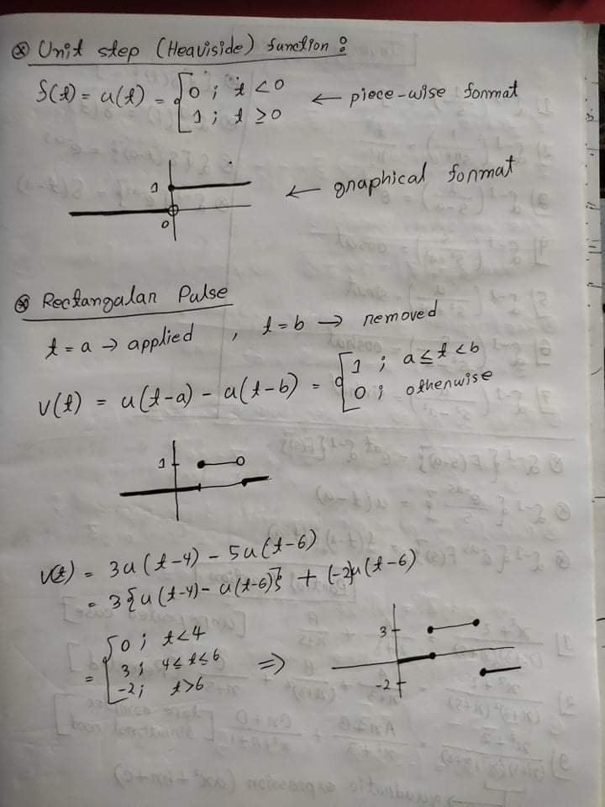

**Lecture-2**

**Inverse Laplace transforms:**

If the Laplace transform of a function is  i.e., if then is called the inverse Laplace transforms of and we write

**Important formulae of Inverse Laplace transformation:**

|  |  |  |  |
| --- | --- | --- | --- |
| 1 |  | 2 |  |
| 3 |  | 4 |  |
| 5 |  | 6 |  |
| 7 |  |  |  |

**First translation property:**

**If then**

**unit step function**’s

**Lecture-3**

**Application of Laplace transformation**

The Laplace transformation is useful in solving differential equations. There are four steps to follow, such as

Differential equation

Apply Laplace Transformation

Use the Initial Values

Solve the algebraic equation for 

Apply Inverse Laplace Transformation.

**Important formulae**

where and are the initial values of and.

The general case for the Laplace transforms of an th derivative is

**Lecture-4**

**Complex Numbers**

A complex number is the form  where and are real numbers and is called the imaginary unit, has the property that or . In general, if is any positive number, we would write:

If , then is called the real part of and is called the imaginary part of *z* and are denoted by  and  respectively. From this, it is obvious that two complex numbers and are equal if and only if and, that is, the real and imaginary components are equal. If the number is said to be purely imaginary, if the number is real.

The standard rectangular form of a complex number is. The symbol , which can stand for any of complex numbers, is called a complex variable.

**Powers of imaginary unit **

Power of imaginary unit are given below:





One can prove by induction that for any positive integer 



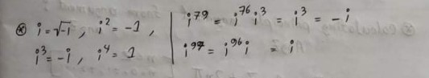

**De`Moivre's Theorem**

De`Moivre's Theorem is a generalized formula to compute powers of a complex number in its polar form

If and n are positive integers, then

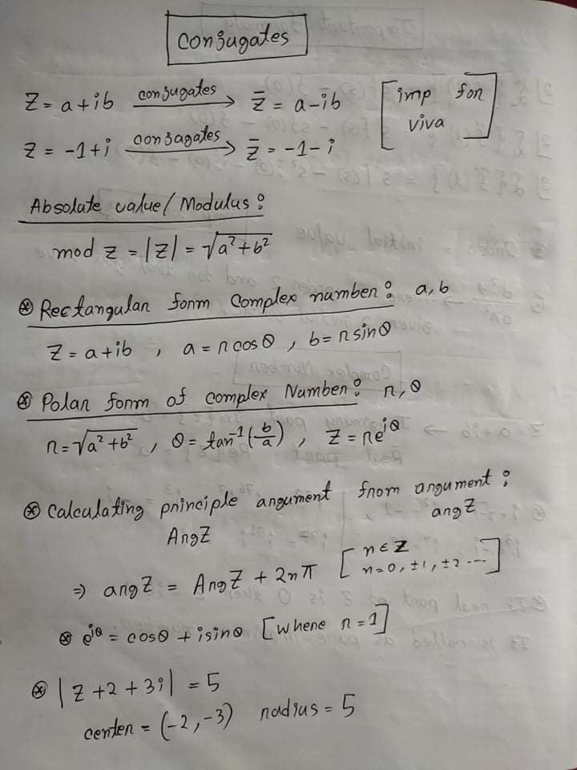

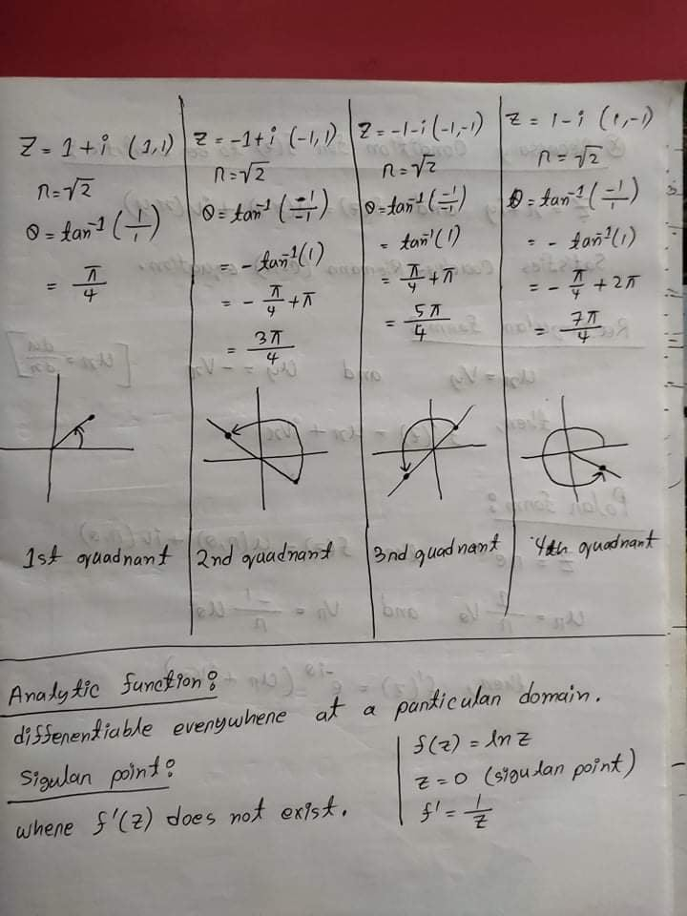

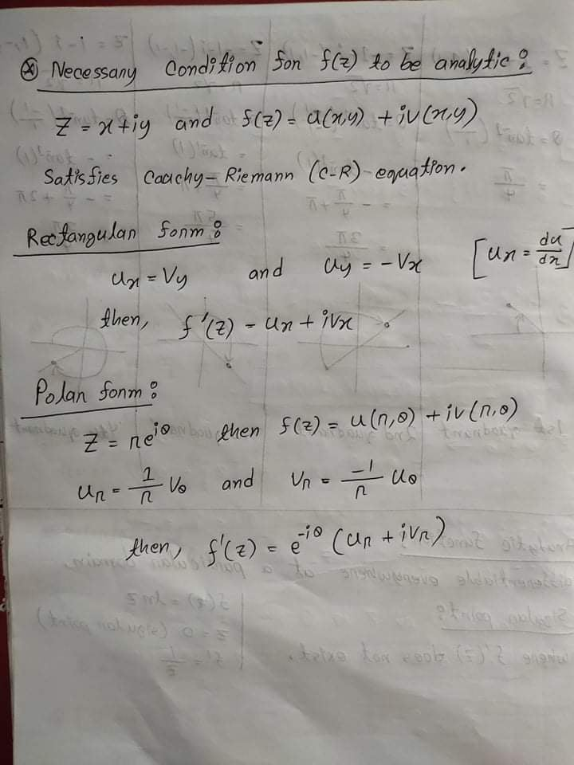

**Important Formulae:**

|  |  |
| --- | --- |
|  |  |
|  |  |
|  |  |

**Cauchy-Riemann Equation when applicable to polar form,**

1. **Power 4 or more then 4.**
2. **Power negative.**
3. **Power fraction.**

